Project Development Phase Model Performance Test

Date | 29 September 2026
Team ID | SWTID-2026-5660
Project Name | Script-Controlled ACL – Restrict Record  Access Based on Field Value
Maximum Marks | 10 Marks

Model Performance Testing:
Project team shall fill the following information in model performance testing template.

S.No. | Parameter | Values | Screenshot
1. | Metrics | ACL Access Metrics: READ Access – EEE branch records are accessible to users with the bb1 role. CREATE Access – Record creation is permitted for users with the bb2 role. WRITE Access – Record modification is permitted for users with the bb3 role. DELETE Access – Record deletion is permitted for users with the bb4 role.  Administrators retain full access. | 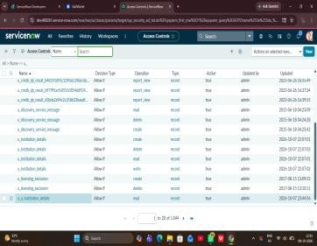
2. | Tune the Model | ACL Configuration and Validation: Role-based ACL configuration using bb1, bb2, bb3 and bb4. READ access is additionally restricted using the Branch = EEE data condition. ACL behavior is verified through authorized and unauthorized user access tests. | 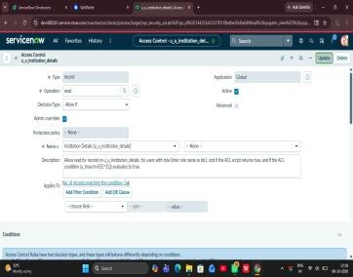

Project Development Phase Model Performance Test

Date | 29 September 2026
Team ID | SWTID-2026-5660
Project Name | Script-Controlled ACL – Restrict Record  Access Based on Field Value
Maximum Marks

Model Performance Testing:
Project team shall fill the following information in model performance testing template.

S.No. | Parameter | Screenshot / Values
1. | Data Rendered | 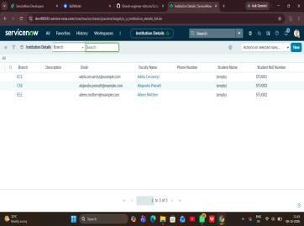
2. | Data Preprocessing | 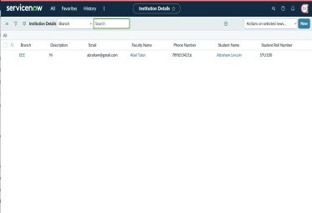
3. | Utilization of Data Filters | 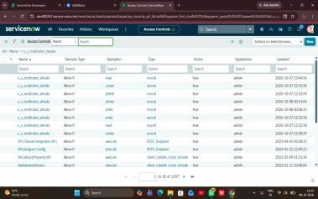
4. | DAX Queries Used | Not Applicable – DAX queries are not used in the ServiceNow ACL implementation.
5. | Dashboard design | Not Applicable – The project focuses on ServiceNow record-level access control and does not require dashboard visualizations.  No of Visualizations / Graphs - 0
6 | Report Design | Not Applicable – No Power BI-style report or graphical visualization is used. The project focuses on ACL-based record security.  No of Visualizations / Graphs -0

Project Development Phase Model Performance Test

Date | 29 September 2026
Team ID | SWTID-2026-5660
Project Name | Script-Controlled ACL – Restrict Record  Access Based on Field Value
Maximum Marks

Model Performance Testing:
Project team shall fill the following information in model performance testing template.

S.No. | Parameter | Values | Screenshot
1. | Project Summary | The project implements a script-controlled Access Control List (ACL) in ServiceNow to restrict access to records based on the Branch field and user roles. The u_institution_details table contains student records with ECE, EEE and CSE branch values. The READ ACL allows users with the bb1 role to access EEE records, while administrators retain full access. CREATE, WRITE and DELETE operations are controlled using bb2, bb3 and  bb4 roles respectively | 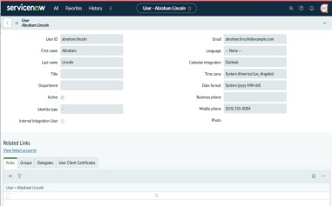
2. | Access Control Accuracy | READ: Users with the bb1 role can view EEE branch records, while users without the required role are denied access. CREATE: Users with bb2 can create new records. WRITE: Users with bb3 can edit permitted EEE records. DELETE:Users with bb4 can delete permitted EEE records.  Administrators retain full access. | 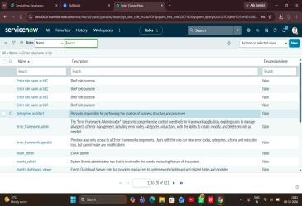
3. | ACL Decision Consistency | The configured ACLs  consistently evaluate the user's assigned roles and the Branch

 |  | field condition before granting access. The READ ACL restricts records to the EEE branch for authorized users, while CREATE, WRITE and DELETE  operations require their respective roles. Unauthorized users are prevented from performing restricted operations. | 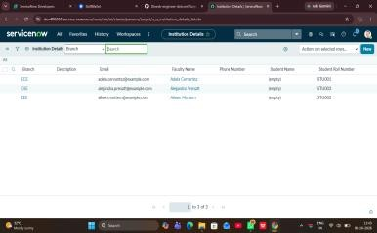

Project Development Phase Performance Test

Date | 29 September 2026
Team ID | SWTID-2026-5660
Project Name | Script-Controlled ACL – Restrict Record  Access Based on Field Value
Maximum Marks

Model Performance Testing:
Project team shall fill the following information in model performance testing template.

S.No. | Parameter | 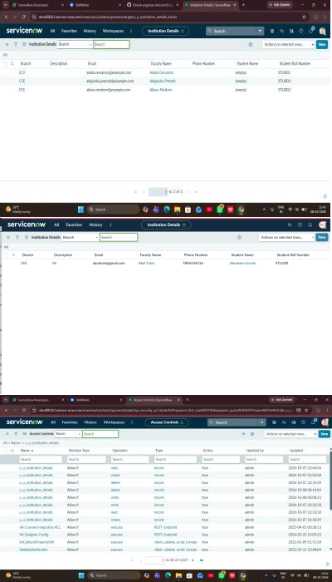  Screenshot / Values
1. | Data Rendered
2. | Data Preprocessing
3. | Utilization of Filters
4. | Calculation fields Used | Not Applicable – No calculation fields are used in this project. Access control is implemented using role-based permissions, conditions, and server-side scripting through ACLs.
5. | Dashboard design | Not Applicable – The project focuses on ServiceNow record-level access control and does not require dashboard visualizations.  No of Visualizations / Graphs - 0
6 | Story Design | Not Applicable – No story or visualization page is required for this project. The project focuses on implementing ServiceNow Access Control (ACL) and  restricting record-level access based on roles and field

values.
No of Visualizations / Graphs -0

User Acceptance Testing (UAT) Report
Project: Script-Controlled ACL – Restrict Record Access Based on Field Value

Date | 29 September 2026
Team ID | SWTID-2026-5660
Project Name | Script-Controlled ACL – Restrict Record Access Based on Field Value
Maximum Marks

Project Overview

Project Name | Script-Controlled ACL – Restrict Record Access Based on Field Value
Project Description | This lab implements a script-controlled Access Control List (ACL) in ServiceNow to restrict record access based on user roles and the Branch field. Users with the bb1 role can view EEE branch records, while administrators retain full access. CREATE, WRITE and DELETE operations are controlled through bb2, bb3 and bb4 respectively.
Project Version | Version 1.0
Testing Period | 3 October 2026
Testing Scope | User and role configuration; u_institution_details table; READ ACL with Branch = EEE condition and script; CREATE, WRITE and DELETE ACLs; administrator access; authorized and unauthorized access verification.
Testing Environment | ServiceNow web-based administration environment
URL/Location | ServiceNow instance; custom table: u_institution_details
Credentials | Use the team's configured ServiceNow test/admin accounts. Passwords are not recorded in this report.
Test Cases

Test Case ID | Test Scenario | Test Steps | Expected Result | Actual Result | Pass/Fail
TC-001 | READ – authorized EEE user | Impersonate EEE User; open u_institution_details.list; review records. | bb1 user can view permitted EEE records. | EEE User can view the permitted EEE branch records. | PASS
TC-002 | READ – unauthorized user | Use a user without bb1; open u_institution_details.list. | User without the required role cannot view protected records. | User without the role is restricted from viewing the records. | PASS
TC-003 | Administrator access | Impersonate Admin; open u_institution_details.list; review records. | Admin can view all records regardless of branch. | Admin can view all records regardless of branch. | PASS
TC-004 | CREATE ACL | Use bb1 + bb2; open the table; check New and create a record. | Authorized user can create a new record. | bb1 + bb2 user can access New and create a record. | PASS
TC-005 | WRITE ACL | Use bb1 + bb2 + bb3; open an EEE record; edit and save. | Authorized user can modify permitted EEE records. | bb1 + bb2 + bb3 user can view and edit EEE records. | PASS
TC-006 | DELETE ACL | Use bb1 + bb2 + bb3 + bb4; open an EEE record; delete it. | Authorized user can delete permitted EEE records. | User with all four roles can delete EEE records. | PASS
TC-007 | ACL decision consistency | Evaluate roles and Branch = EEE condition for authorized and unauthorized access. | ACL behavior follows configured role and field conditions consistently. | Access behavior follows the configured ACL requirements. | PASS

Bug Tracking

Bug ID | Bug Description | Steps to reproduce | Severity | Status | Additional feedback
N/A | No defect/bug is reported in the project verification information provided. | Not applicable. | N/A | No bug recorded | Update this table if a defect is found during final review.
Sign-off

Tester Name

Date | 3 October 2026
Signature

Notes
- Ensure that test cases cover both positive and negative scenarios.
- Test cases in this report reflect the ACL verification statements supplied for the completed project.
- Bug tracking should include severity, status and reproduction steps if an issue is discovered.
- Final tester/project-owner sign-off should be completed by the actual responsible team member.
- Regression, classification, MAE, MSE, RMSE and other ML-model metrics are not included because this project is a ServiceNow ACL implementation, not an AI/ML model.

UAT Result Summary: PASS for the documented verification scenarios, based on the project verification statements provided.

Project Development Phase
Model Performance Test

Date | 29 September 2026
Team ID | SWTID-2026-5660
Project Name | Script-Controlled ACL – Restrict Record  Access Based on Field Value
Maximum Marks

Model Performance Testing:
Project team shall fill the following information in model performance testing template.
S.No. | Parameter | Values | Screenshot
 | Model Summary | -
 | Accuracy | Training Accuracy -  Validation Accuracy -
3. | Fine Tunning Result( if Done) | Validation Accuracy -

Functional & Performance Testing Template
Model Performance Test

Date | 29 September 2026
Team ID | SWTID-2026-5660
Project Name | Script-Controlled ACL – Restrict Record Access Based on Field Value
Maximum Marks

Test Scenarios & Results

Test Case ID | Scenario | Test Steps | Expected Result | Actual Result | Pass/Fail
FT-01 | READ ACL Access Test | Log in with the configured user and try to view the protected record. | Access should be allowed or denied according to the configured READ ACL condition. | Access was controlled correctly. | PASS
FT-02 | CREATE ACL  Access Test | Log in with the configured use and try to create a new record in the project table. | Record creation should be allowed or denied according to the configured CREATE ACL  condition. | Record creation was controlled correctly. | PASS
FT-03 | WRITE ACL Access Test | Open an existing record, modify its field value and try to save the changes | Record modification should be allowed or denied according to the configured WRITE ACL  condition. | Record update was controlled correctly | PASS
FT-04 | DELETE ACL Access Test | Open an existing record and try to delete it using the configured user. | Record deletion should be allowed or denied according to the configured DELETE ACL  condition | Record deletion controlled correctly. | PASS
PT-01 | ACL Response Time Test | Perform READ, CREATE, WRITE  and DELETE operations on the configured table. | Each operation should be evaluated according to its applicable ACL rule | No noticeable delay. | PASS
PT-02 | Multiple ACL Operation Test | Perform multiple READ, CREATE, WRITE and DELETE  operations using the configured users. | The ACL should consistently allow or deny access according to the configured conditions. | ACL rules worked correctly. | PASS

PT-03 | ACL Consistency Test | Repeat authorized and unauthorized access operations using the configured users. | Should work smoothly without crashing | Results were consistent. | PASS

